**Module-3: Docker – I Assignment – 2**

**● Save the image created in Assignment 1 as a Docker image.**

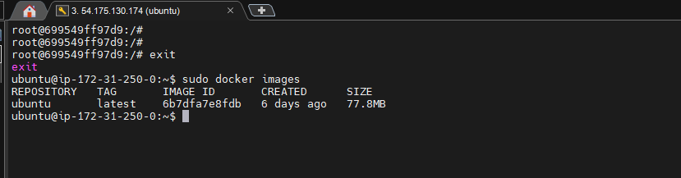

**● Launch container from this new image and map the port to 81.**

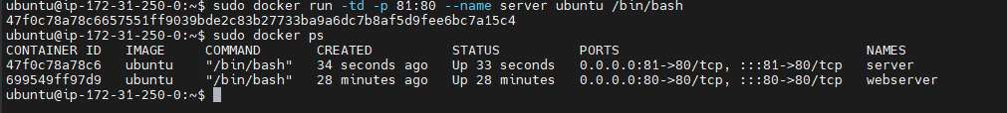

**● Go inside the container and start the apache2 service**

